**User Guide for Belleville Dental Hospital Website**

1. **Getting Started**
   * **Accessing the website (**[www.belleville.com](http://www.belleville.com)**)**
   * **Supported browsers:** Edge, Chrome, Mozilla, Firefox, safari.
   * **Operating Portal:** Windows.
   * **Supported Devices:** Responsive.
2. **Homepage**
   * Overview of the homepage layout.

**1: Logo & visitor counter**



**2: Navigation**

* With Search functionality



**3: Easy Navigation with Option Fade in Out, hover, Color Change on Click and Filter on Products Link.**

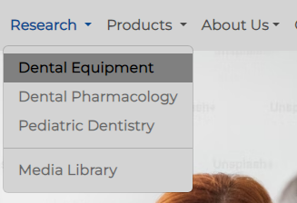

**4: Slider with topic Patient Education, Professional Education, Research.**

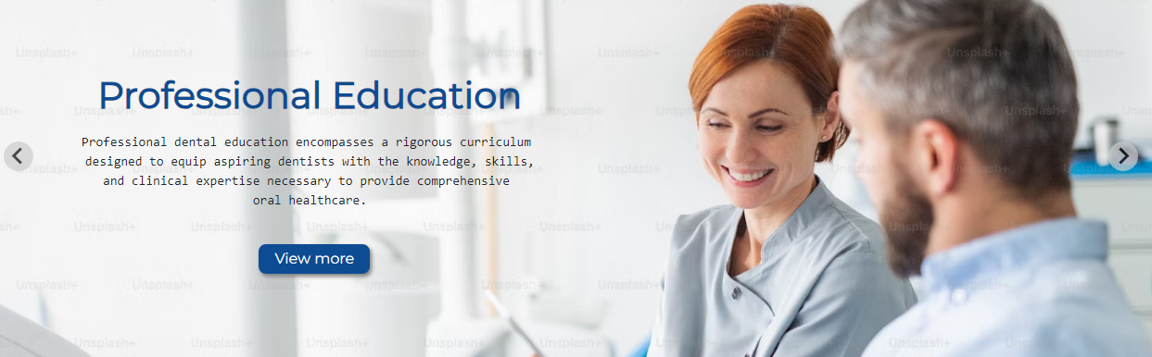

**5:** **Contact Information**, **Geolocation, Appointment Booking**

* + Step-by-step guide on how to schedule an appointment
  + Information required for booking
  + How to submit necessary documents online
  + Location, phone number, and email details

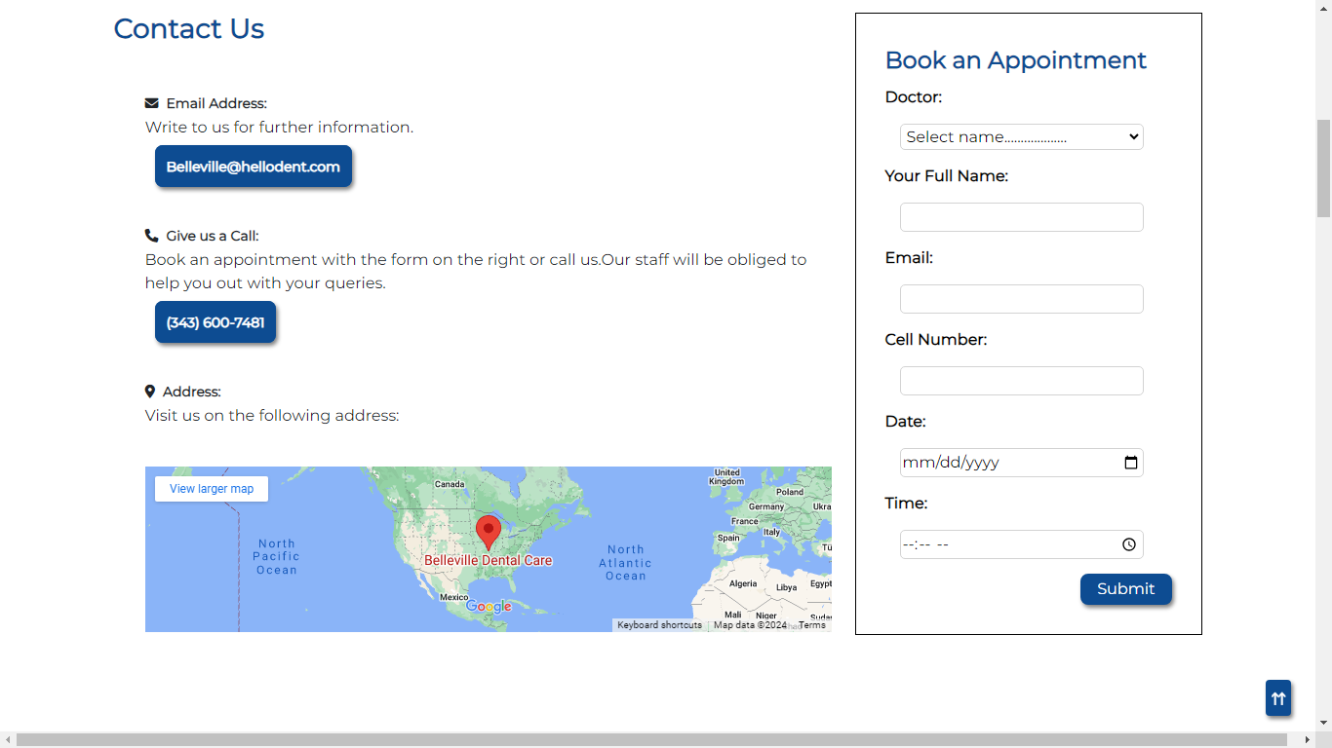

**6: Our Services**

* + Description of dental services offered
  + 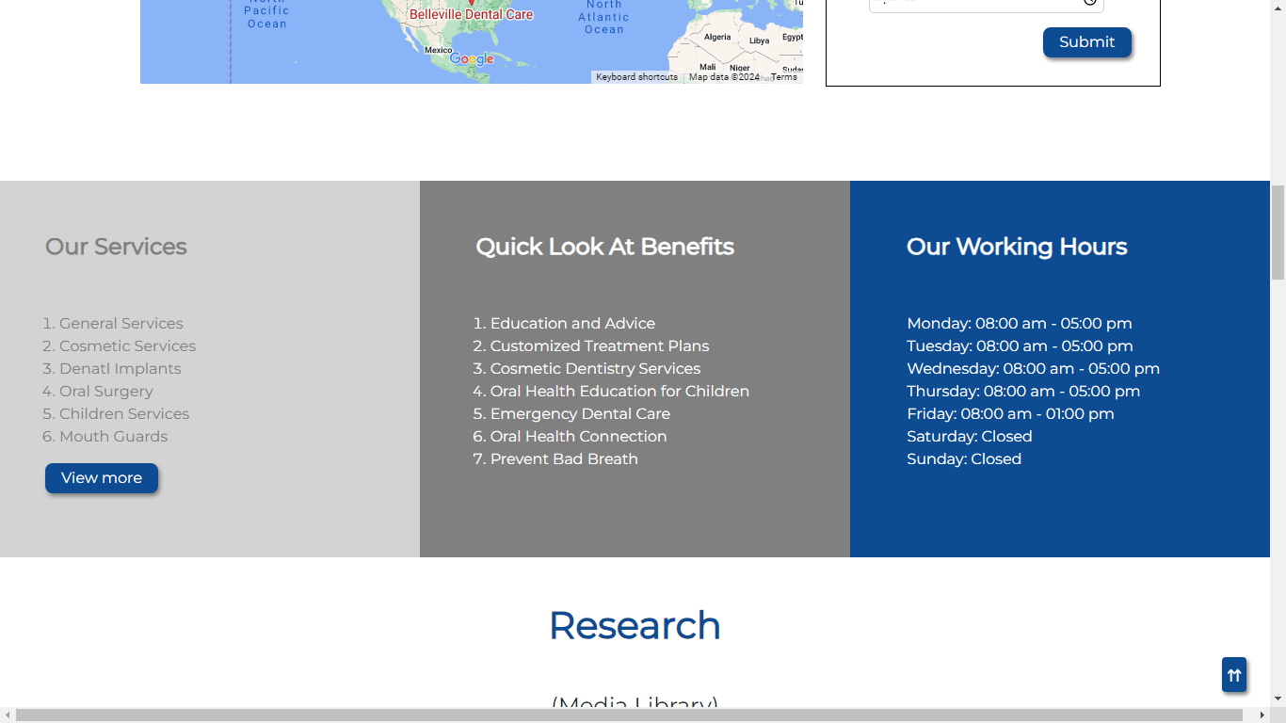How to navigate through different service categories

**7: Our Research Video**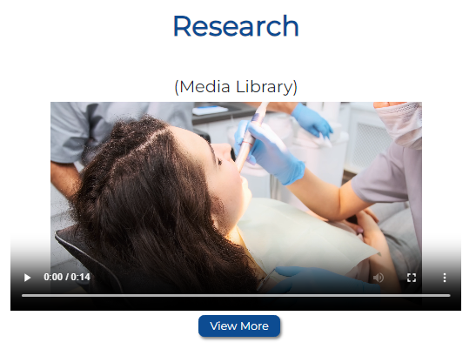

**8: Over View on Our Gallery**

* Slider option

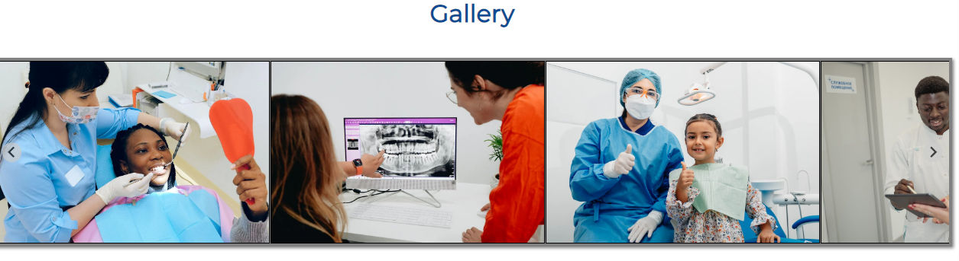

**9: Our Team Members**

* + Introduction to the dental hospital team

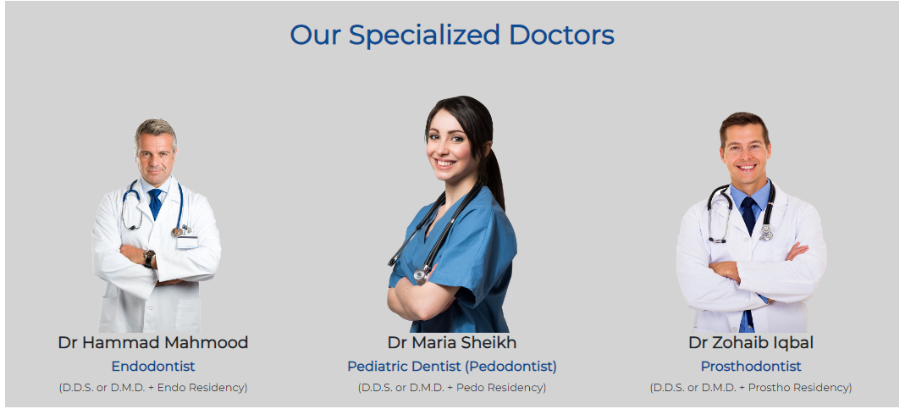

**10: Product with Rating**

**Bamboo Toothbrush:**

* Material: Bamboo toothbrushes have handles made from sustainable bamboo, a biodegradable and renewable resource.

**Toothpaste:**

* + Ingredients: Natural toothpaste formulations often include plant-based ingredients, essential oils, and minerals. Some may exclude artificial preservatives, colors, and flavors.

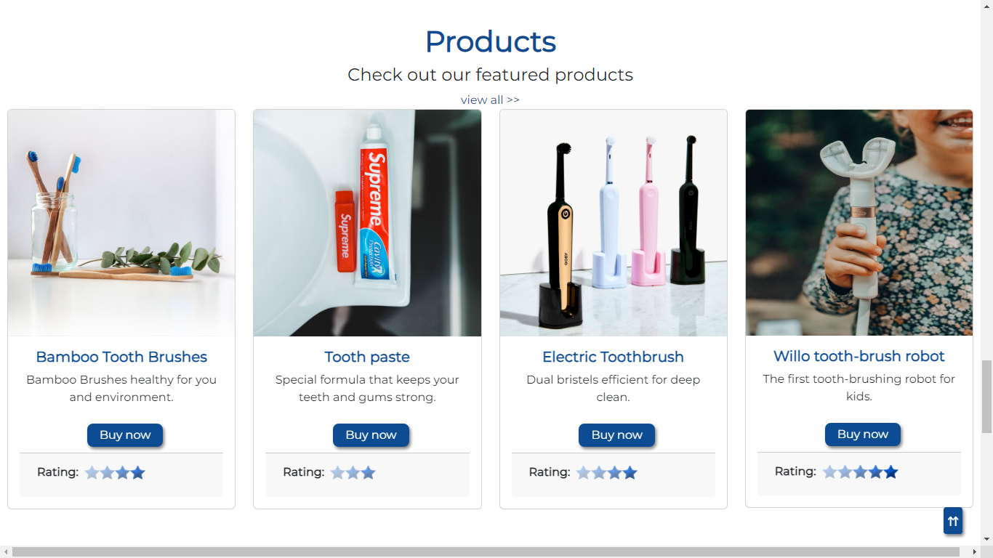

**11: Contact Us**

* Contact details for technical support



**12: Testimonial**

1. **Feedback**

* How users can provide feedback or report issues
* Commonly asked questions and their answers

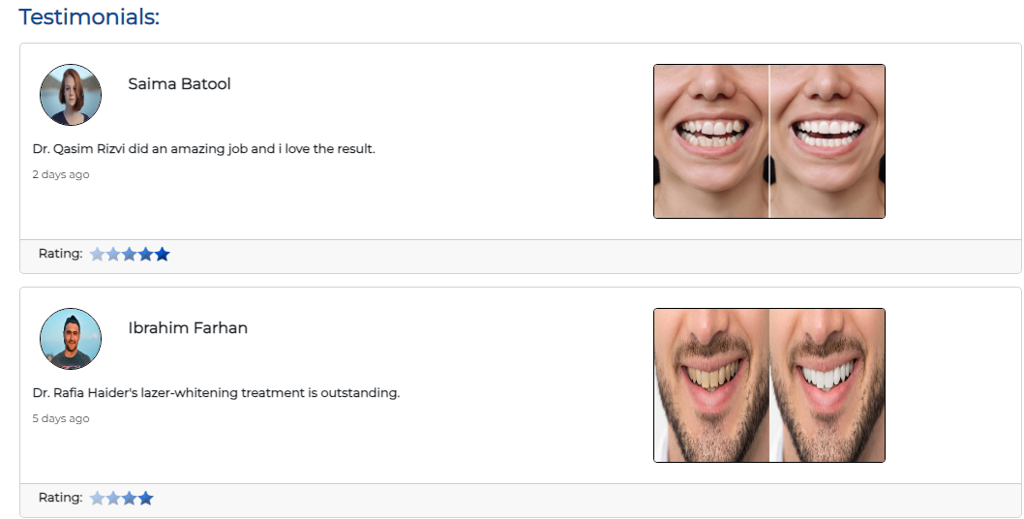

**13: Footer**

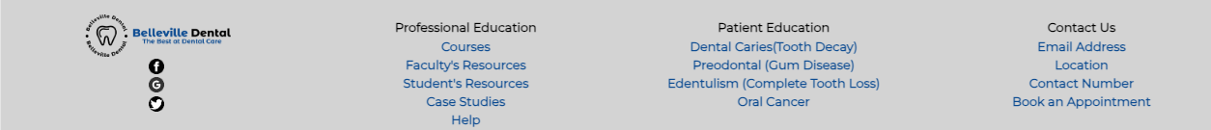

**14: Continuous Scrolling Date, Time and Geolocation**



**15: Scroll Up for Easy Handling webpage at the Bottom.**



**Conclusion**

Thank you for choosing Belleville Dental Hospital's website as your source of dental information and services. We appreciate your trust in us. If you have any further questions or if there's anything we can assist you with, please don't hesitate to reach out. Your oral health is important to us, and we look forward to serving you. Wishing you a bright and healthy smile!